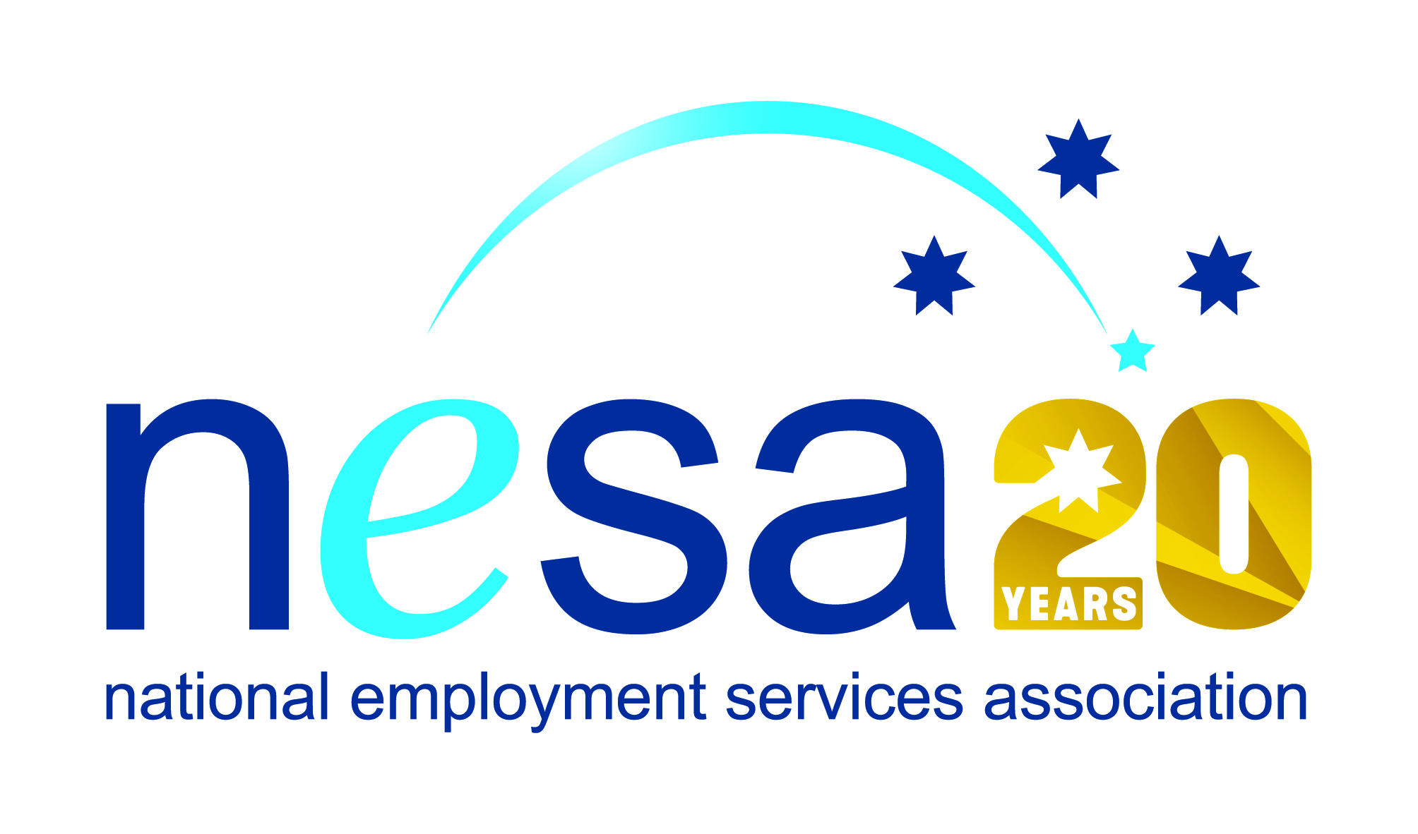

MEDIA RELEASE
4 AUGUST 2017
Ex-RAAFie recognised for outstanding work in Indigenous employment
Rob Beattie, former Australian Defence Force member (RAAF) has been nominated for the National Employment Services Association (NESA) Excellence in Indigenous Employment Award by atWork, Cannington, in recognition of his exceptional service to the local Indigenous community. This is one of five Awards for Excellence offered each year by NESA for outstanding performance and achievement within the employment services sector.
Rob’s 25 years serving his country were not enough to dampen his altruistic and compassionate nature. Once retired from the military, he started working in employment services, where his solid dependability and excellent managerial and people skills saw him rise quickly through the ranks.
Rob has been working with atWork since 2013, where his good-natured and tireless dedication has won him great respect and admiration amongst those he has helped. “He goes out of his way to help his job seekers, and within the indigenous community he is well liked and a top bloke,” said one of Rob’s clients, or ‘mates’ as they often refer to themselves: “He also gives me and other mates lifts when he sees us on the street.”
Over the course of his time in employment services, Rob has developed close and effective relationships with a number of Indigenous organisations in the Perth metropolitan area including the Aboriginal Workforce Development Centre (AWDC), the Derbal Yerrigan Health Service and Aboriginal Hostels Ltd. He also teaches job seeking classes for the Aboriginal Services Unit at South Metropolitan TAFE.
Trusted and respected, Rob’s dedication and hard work are evident in his exceptional retention rate: 70% of his clients achieve their 52 week stable employment landmark, as opposed to around 38% for other programmes.
“Rob shows a very good understanding of Aboriginal people and has a deep respect for our culture and is compassionate to the range of issues that many Aboriginal people face,” said Michele Halse Aboriginal Workforce Development Consultant, South Metropolitan TAFE. “He has a great sense of humour and works steadily to provide skills and motivation to the Aboriginal clients of each program as well as being a mentor.”
“Rob Beattie is the kind of employment services practitioner who makes a positive and lasting impact on people’s lives and well-being,” said Sally Sinclair, NESA CEO. “Although there are thousands like him working tirelessly across the country to improve opportunity for all through employment and inclusion, Rob’s particular devotion and outstanding successes are examples to us all, and his nomination for this award is well-deserved.”
The winner of the NESA Excellence in Indigenous Employment Award will be announced at the NESA National Conference, to be held in Melbourne on the 22nd- 23rd of August, 2017.
The National Employment Services Association Excellence in Indigenous Employment Award is supported by the Australian Government Department of Employment.
…ends/

