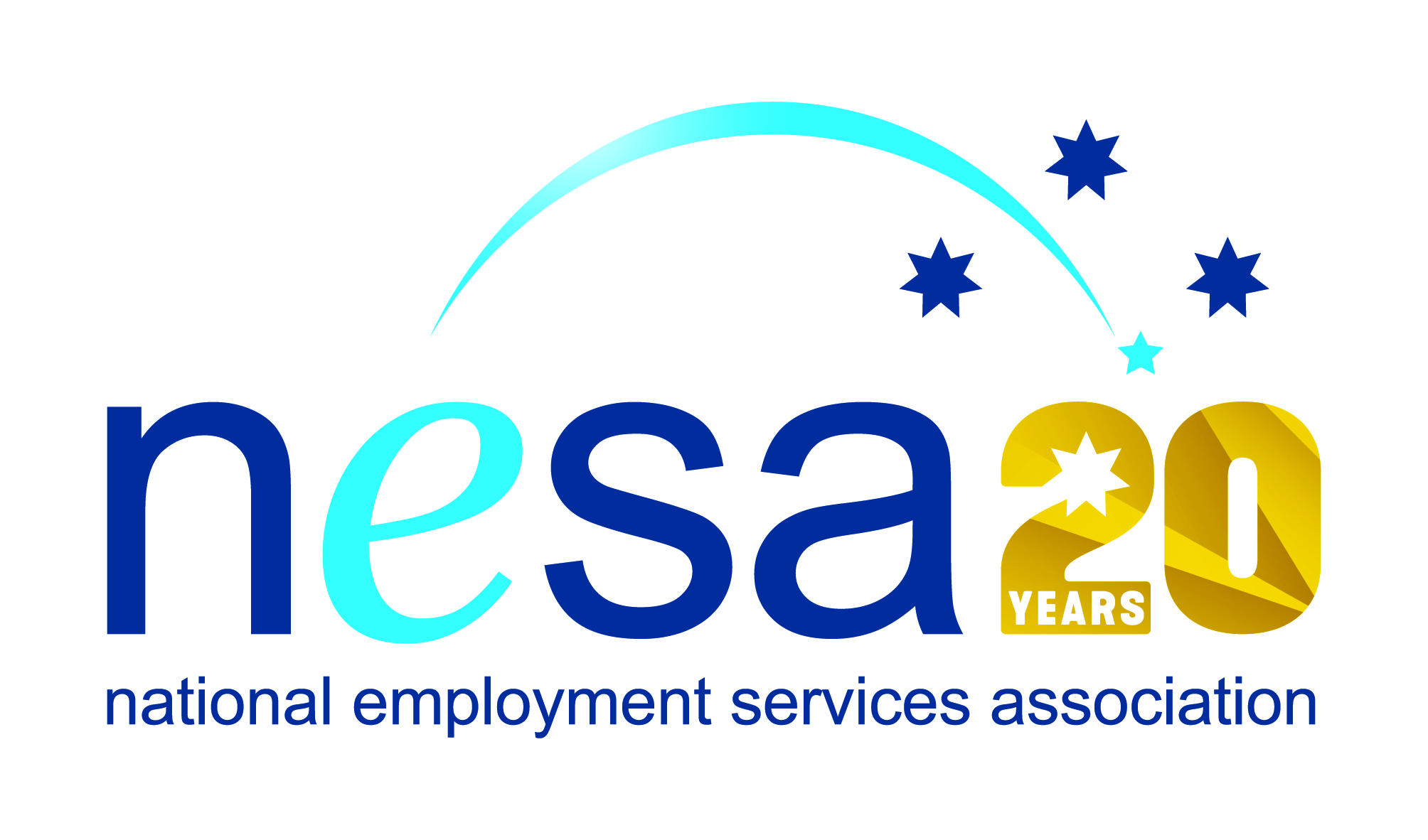

MEDIA RELEASE
4 AUGUST 2017
Silly Yaks for the three-way win!
Coburg-based handmade wheat, gluten and nut-free baked goods manufacturer Silly Yak Foods has been nominated for the National Employment Services Association (NESA) Champion Employer of the Year Award in recognition of their commitment to what they call the “three-way win”: for themselves, for the employment services provider they work with, and for their employees. This is one of five Awards for Excellence offered each year by NESA for outstanding performance and achievement within the employment services sector.
Silly Yak are a local success story, growing from a small Northcote café in 2001 to an international distributor of quality products. As they grew, their commitment to creating a supportive work environment grew with them. In 2013 they formed an exclusive partnership with employment services provider MatchWorks, whom they saw as an organisation sharing their commitment to getting people into secure, permanent, ongoing employment.
Silly Yak only have permanent employees. “By providing an open, inclusive, flexible and family friendly environment, as well as employing people only in permanent positions, we encourage a sense of belonging and community in our staff,” said Managing Director Bryn Pears. Silly Yak look at each potential employer as the person they are now, and what they can bring to the organisation moving forward. “Our staff recruitment process is largely indifferent to the applicant’s past travails. […] what matters is character and desire to work, not mistakes made earlier in life,” he said.
Most of the company’s 18 staff have come to them through the relationship with MatchWorks, either through jobactive, or Disability Employment Services.
“It is very encouraging to see SMEs like Silly Yak embracing the powerful opportunities offered by employment services to improve opportunity and inclusion for disadvantaged Australians,” said NESA CEO Sally Sinclair. “Their highly successful collaboration with valued NESA member MatchWorks is an example to be followed, and we congratulate them on this well-deserved nomination.”
The winner of the NESA Champion Employer of the Year Award will be announced at the NESA National Conference, to be held in Melbourne on the 22nd- 23rd of August, 2017.
The National Employment Services Association Champion Employer of the Year Award is supported by the Australian Government Department of Employment.
…ends/

