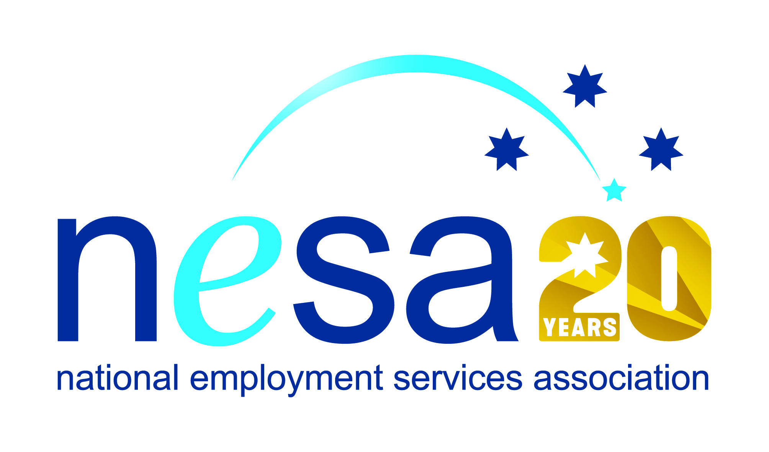

MEDIA RELEASE
4 AUGUST 2017
Smart business integration improves outcomes for all
Albany and Dubbo-based Fletcher International Exports have been nominated for the National Employment Services Association (NESA) Champion Employer of the Year Award. This is one of five Awards for Excellence offered each year by NESA for outstanding performance and achievement within the employment services sector.
In conjunction with SureWay Employment and Training, Fletcher’s (as they are locally known) has built up a dedicated workforce of more than 700 employees, and boasts a high percentage of Indigenous staff, including seven members of the upper management team, and CEO Melissa Fletcher. The company has first-hand knowledge and understanding of the hurdles facing indigenous Australians seeking work, and maintains strong connections with local Indigenous communities in their two locations.
As one of Australia’s most diversely integrated Agribusinesses, specialising in the processing, logistics and farming of sheep and lamb meat products, Fletcher’s has always maintained a particular focus on supporting staff development and internal career management. Their only recruitment requirement is a positive attitude and a willingness to “have a go”, and as a registered RTO, they offer their staff nationally accredited Professional Development courses, guaranteeing constant sustainable career opportunities. Training Officers and Supervisors within Fletcher’s dedicated HR Department provide additional ongoing support where needed.
The cooperation with SureWay assures that pathways into employment are fully supported at every stage. SureWay and Fletcher’s regularly co-host forums on pre-employment training, and cooperate in the assurance of good job seeking and interviewing skills for job seekers.
“Fletcher International Exports are a fine example of a business that understands how to build and maintain a diverse and non-discriminatory workforce,” said NESA CEO Sally Sinclair. “Their approach to staff retention is smart and successful, and it is with pleasure that we see them recognised for their continuing good work with this award nomination.”
The winner of the NESA Champion Employer of the Year Award will be announced at the NESA National Conference, to be held in Melbourne on the 22nd- 23rd of August, 2017.
The National Employment Services Association Champion Employer of the Year Award is supported by the Australian Government Department of Employment.
…ends/

