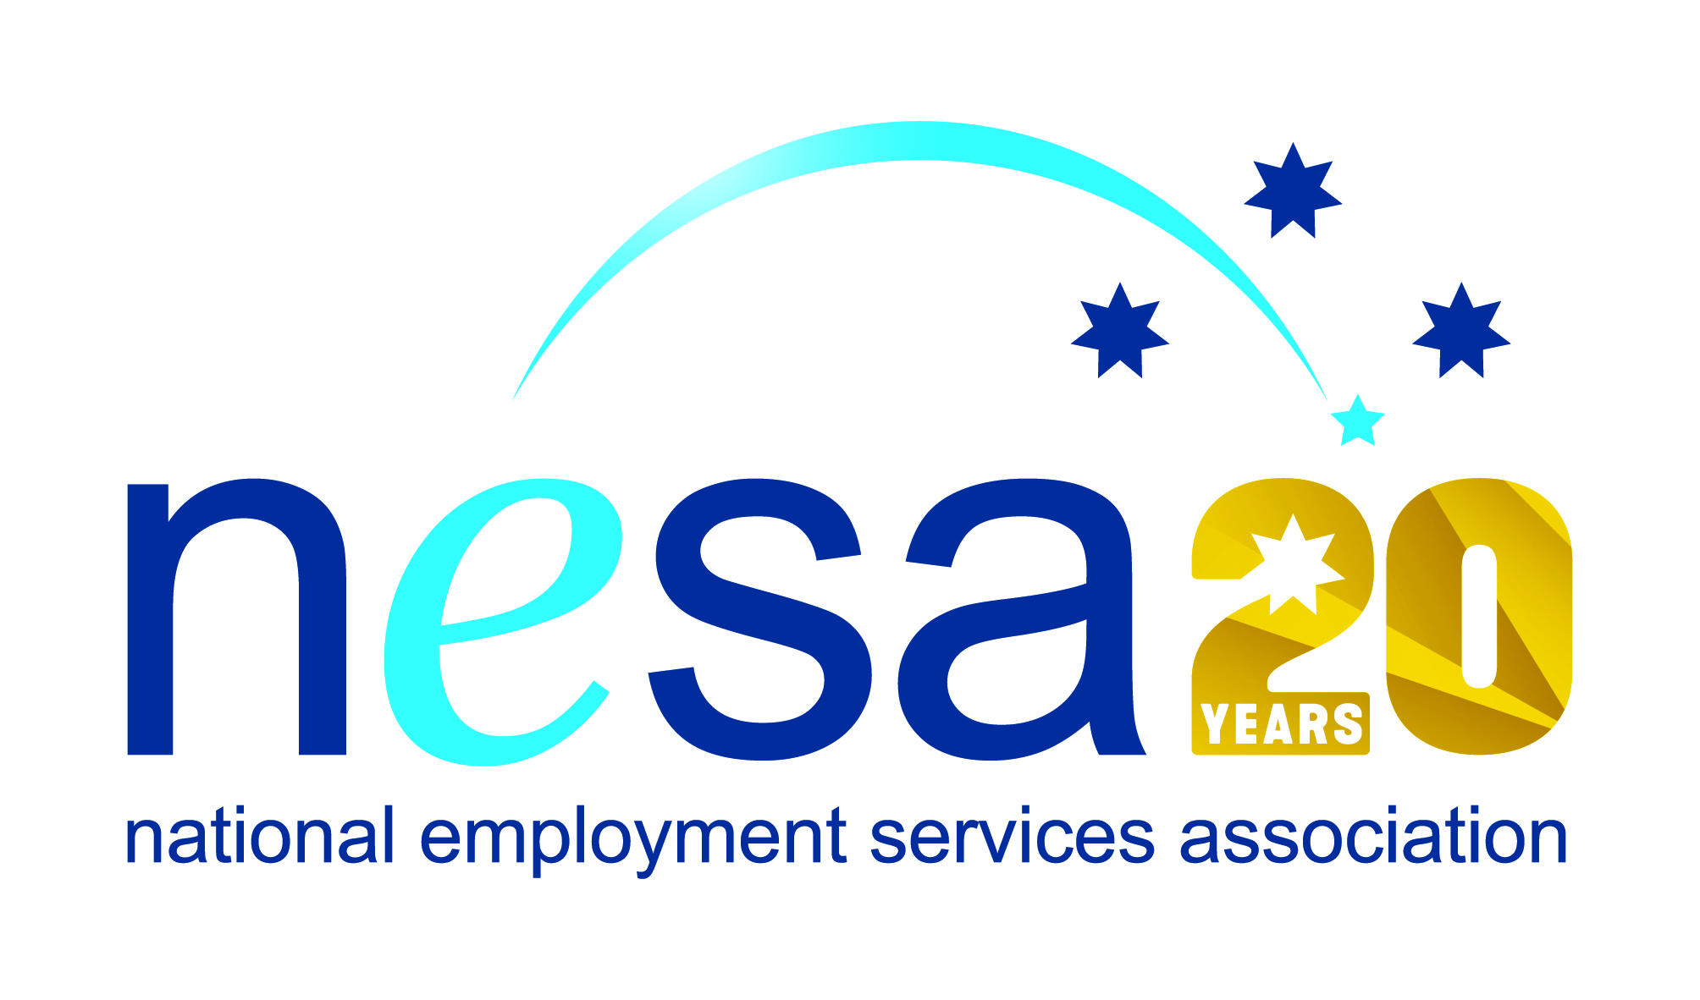

MEDIA RELEASE
4 AUGUST 2017
“Looking beyond the résumé” in disability employment
Campsie-based CoAct Settlement Services International (SSI) has been nominated for the National Employment Services Association (NESA) Innovation in Disability Employment Team Award for their outstanding EmployAbility programme, improving the employment prospects of people with disability. This is one of five Awards for Excellence offered each year by NESA for outstanding performance and achievement within the employment services sector.
EmployAbility grew as a response to extensive requests for support from people with disabilities, carers, and their families. Consultation with SSI’s extensive employer network showed a genuine interest among companies to support entry into the workforce for people with disabilities and ‘give them a go’.
SSI cooperates with a range of social enterprises that offer an unrivalled safe and supported learning environment to accelerate job readiness, to develop confidence, self-belief and a sense of purpose, and to reignite passion in those for whom possibilities for work have all to often been limited or absent.
SSI’s clients are people with disability, but many are also from culturally and linguistically diverse (CALD) backgrounds, compounding the difficulties they face to find employment.
EmployAbility's services connect people with opportunities in the market and set realistic goals informed by available support, skilling and engagement. Through a holistic, end-to-end support model, participants are empowered from the referral stage through to post placement support to ensure the retention in the job and success of the employment outcome.
“SSI’s wrap-around support model is a superb demonstration of how different resources can be brought together in support of a marginalised group of Australians, and to help bring them the employment and independence opportunities that everybody deserves,” said NESA CEO Sally Sinclair. “Congratulations on this well-deserved nomination.”
The winner of the National Employment Services Association Innovation in Disability Employment Team Award will be announced at the NESA National Conference, to be held in Melbourne on the 22nd-23rd of August, 2017.
The Innovation in Disability Employment Team Award is supported by the Australian Government Department of Social Services. …ends/

