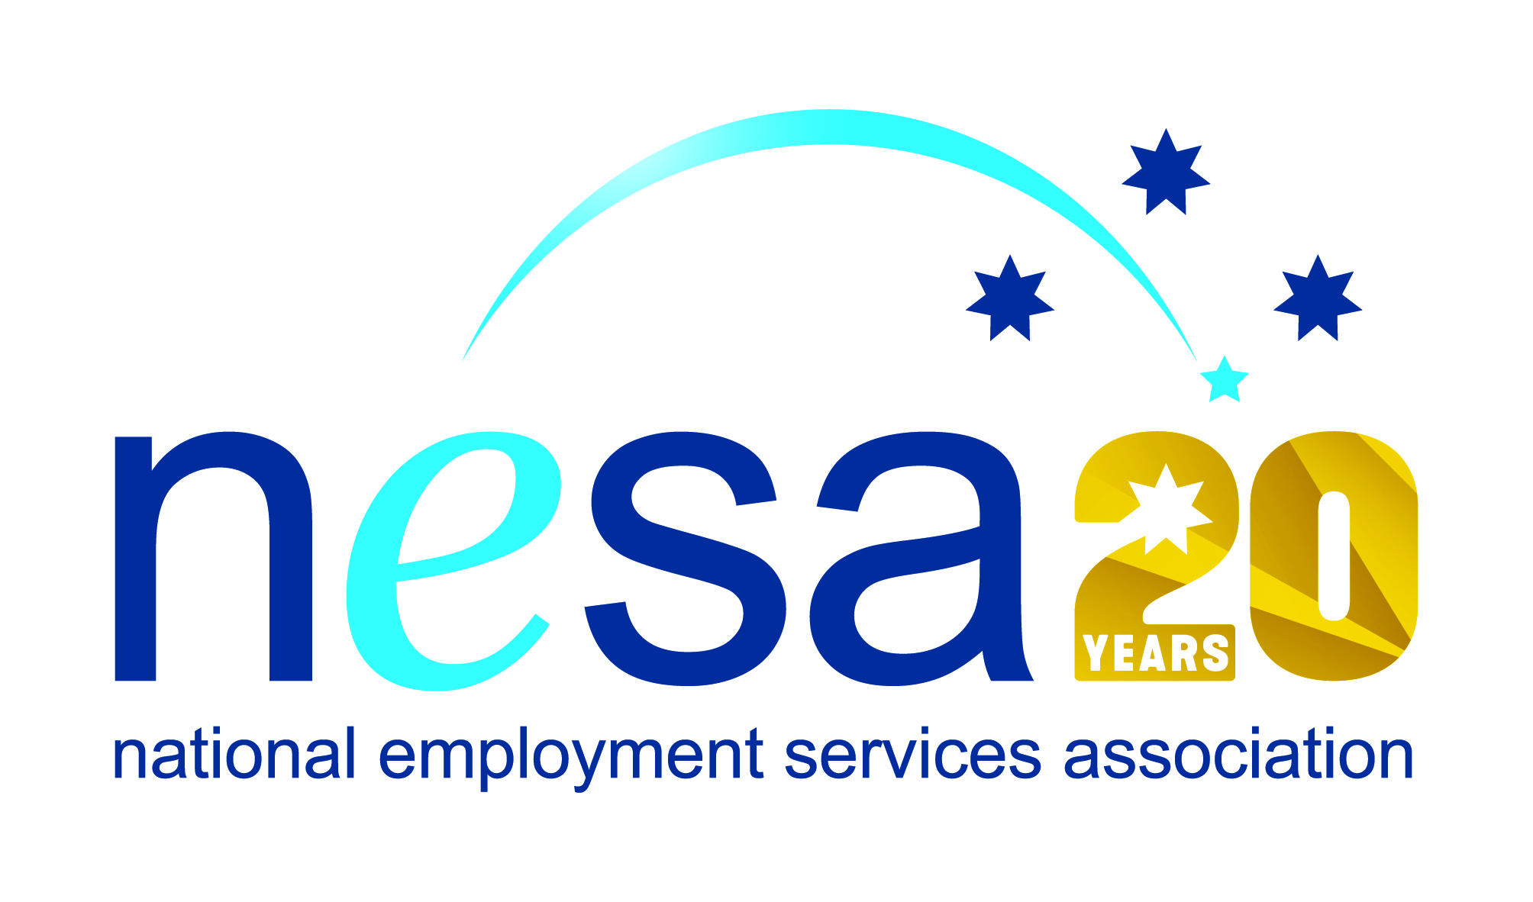

MEDIA RELEASE
4 AUGUST 2017
Bundaberg recycler in line for second national disability award?
CoAct member IMPACT Community Services, Bundaberg, has been nominated for the National Employment Services Association (NESA) Innovation in Disability Employment Team Award, one of five Awards for Excellence offered each year by NESA for outstanding performance and achievement within the employment services sector. If IMPACT win, it will be their second national award this year for projects assisting people with disability, having already been awarded with the NDS Supported Employment Excellence Award in May..
IMPACT’s Bundaberg MRF (Material Recovery Facility) plays an essential role in the recycling process. Last year IMPACT recovered in excess of 7,500 tonnes of recyclable material; they recycled 5,880 tonnes of paper and cardboard, saving the lives of approximately 76,650 trees, and their activities prevented 12,180 tonnes of CO2 from being released into the environment.
But if IMPACT’s achievements for the environment are impressive, their work with and for people with disability is even more so. The Bundaberg facility has 33 staff, 27 of whom are people with disability. Working effectively and respectfully with people with disability is IMPACT’s top priority, so when the salary categories provided by existing disability support structures and assessment tools didn’t seem right, they created their own assessment tools, resulting in improved working conditions and a net salary increase for all their staff.
IMPACT have become advocates for the employment rights of people with disability in general, and are leading the way in many areas of disability employment. Their own approach to supporting and assisting their staff has resulted in extremely high levels of employee satisfaction and engagement, with the resultant excellent returns in terms of productivity and service. The supported employees know they are part of the IMPACT team and that the work they do is contributing to the local environment and economy and that they are needed, appreciated and relied on.
“IMPACT chose their name well!” said Sally Sinclair, NESA CEO. “Their work positively impacts the environment, the lives of their employees and the prospects and situation of people with disability everywhere. Their business model is an inspiring example of what can be done with imagination, compassion and a genuine desire to make a difference. Congratulations on this well-deserved nomination!”
The winner of the National Employment Services Association Innovation in Disability Employment Team Award will be announced at the NESA National Conference, to be held in Melbourne on the 22nd-23rd of August, 2017.
The Innovation in Disability Employment Team Award is supported by the Australian Government Department of Social Services.
…ends/

