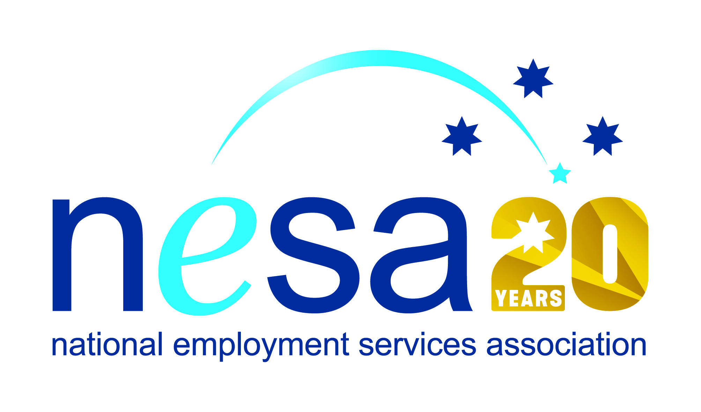

MEDIA RELEASE
4 AUGUST 2017
Crown and atWork Australia recognised for focus on ability
Crown Resorts and atWork Australia have joined forces with CROWNability: a ground-breaking approach to opening employment opportunities to people with disability. The CROWNability partnership has been nominated for the National Employment Services Association (NESA) Innovation in Disability Employment Team Award, one of five Awards for Excellence offered each year by NESA for outstanding performance and achievement within the employment services sector.
Crown is fully committed to creating an inclusive work environment. That commitment began with initiatives to address gender and cultural diversity and then moved to a focus on employment opportunities for Indigenous Australians and people with disability. From the outset CROWNability, as the name indicates, is focussed on designing an employment model that considers what a person with disability can do, as opposed to what they cannot.
With the help of the Disability Employment Services provider atWork, Crown has learnt where the difficulties lie for people with disability in traditional recruitment processes, and have modified their recruitment and training logic accordingly.
The positive collaboration between Crown and atWork means that job seekers with disability are supported throughout the entire application, onboarding and post-placement process. Should Crown not be the right fit, these job seekers are then considered for other organisations or businesses and remain under the guidance of atWork staff to gain suitable employment.
The successes of the programme speak for themselves: 151 people with disability offered positions at Crown’s Perth and Melbourne centres alone in the first 18 months of the programme’s operation, of which 78 turned into stable full-time employment.
“There is sometimes a stigma associated with disability, especially for those like me with an invisible disability. Working at Crown is different as I get the support that I need and treated with respect,” said one new employee. Another added, “The CROWNability program ultimately helped me find a job. I blend in just like everyone else here at Crown and don't get treated any different, which is good.”
NESA CEO Sally Sinclair praised the collaboration, saying “The CROWNability initiative is an excellent example of how employers and employment services can combine experience, positive goals and imagination to find new ways to manage the transition into work for those with barriers to traditional employment processes. NESA is proud to acknowledge such fantastic work with a nomination for the Innovation in Disability award.”
The winner of the National Employment Services Association Innovation in Disability Employment Team Award will be announced at the NESA National Conference, to be held in Melbourne on the 22nd-23rd of August, 2017.
The Innovation in Disability Employment Team Award is supported by the Australian Government Department of Social Services
…ends/

