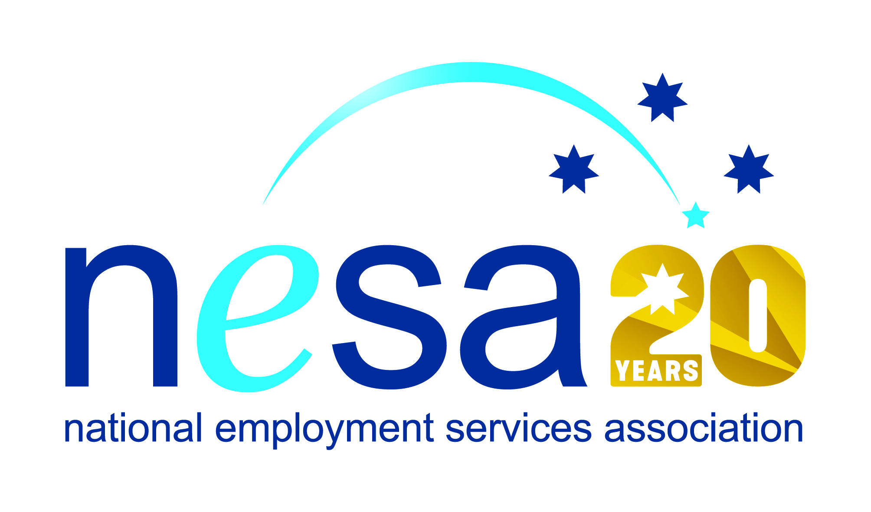

MEDIA RELEASE
22 AUGUST 2017
Kayleen Perotto’s determination to achieve leads to national award
Kayleen Perrotto, of Interact People Solutions, Mudgee is the 2017 National Employment Services Association (NESA) Employment Consultant of the Year. She joins 6 other people and organisations honoured in the NESA Awards for Excellence ceremony held this evening at the Pullman Melbourne on the Park, as part of NESA’s 2017 National Conference.
“Kayleen is the kind of person who empowers you with her smile,” said NESA CEO, Sally Sinclair. “Helping people into employment can be hard and draining work, but irrepressible spirits like Kayleen light the way, and recharge the batteries of everybody around them!”
In her role as a Senior Employment Consultant with Interact People Solutions, Kayleen assists diverse job seekers to overcome adversity and disadvantage and to realise their employment aspirations.
Interact’s Mudgee site has a 5 Star performance rating and this is largely due to Kayleen’s ability to genuinely connect with job seekers, even those with the hardest of exteriors.
Star ratings are independently calculated by the Federal Government Department of Employment, and reflect an employment services provider effectiveness in getting people into work.
“She is known in the Mudgee community as someone who will explore every option to get results for her clients,” says her Manager, Margret Irish. Kayleen has received 3 Awards of Appreciation from employers that she has supported to provide inclusive employment opportunities to job seekers.
Kayleen has developed innovative peer support groups and training programs. She actively pursues and shares better practice with her colleagues at Interact and with community partners with a common mission to address disadvantage and assist job seekers.
“It’s not about the ‘knock down’ but about the ‘get up’” Kayleen said, smiling. She fundamentally believes that passion for what you do, a positive outlook, proactive advocacy and belief in others can achieve amazing results.
And Kayleen knows what it takes to lift yourself up and turn your life around, having overcome significant adversity herself. She found the courage to flee family violence with her two young children and start a new life. Not having any qualifications, she undertook a Certificate IV in Community Studies, then a Certificate III in Nursing and has now commenced a degree in Psychology. Kayleen has not let anything get in her way, also overcoming a broken back and grief of losing a family member.
Kayleen’s particular strength derives from her ability to remain focussed on the good. Described as an “engaging, proactive and positive individual”, she believes that everyone has the ability to make a meaningful contribution to society and to life.
NESA joins Interact People Solutions in congratulating Kayleen on her well-deserved win.
…ends/

