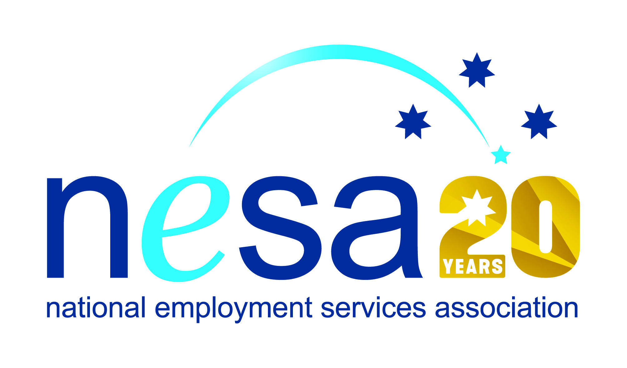

MEDIA RELEASE
3 AUGUST 2017
“Everyone needs to be treated with respect...” says national award nominee
Casey Dickinson, Employment Consultant at CoAct Community Solutions, Cannonvale has been nominated for the National Employment Services Association (NESA) Employment Consultant of the Year Award as a result of her exceptional work with the people of the Whitsunday region, devastated by Cyclone Debbie in March of this year. This is one of five Awards for Excellence offered each year by NESA for outstanding performance and achievement within the employment services sector.
Casey is young for the role. At just 21, she found herself in charge of a caseload of over 200 clients, many of whom had been displaced by the storms and who were in dire straits. But Casey quickly impressed with her maturity and application, as well as her understanding of the particular labour market in the region. “You don’t strike people with her work ethic often,” said Peter Lindsay, Casey’s manager. “She has a great rapport with all stakeholders and she’s always looking for ways to improve people’s lives and outcomes.”
When Casey began working at the Cannonvale site, it was rated at 2 Stars. Just two years later, the site has a 5 Star rating, and for most of that time, Casey was virtually running the show single-handed. With the encouragement of her employers, she is now looking to move into a management role.
“The biggest thing that keeps me going is the idea that ‘this person needs help’,” she said, and that is surely her secret: Casey is a level-headed and organised young woman, but she is also keenly attuned to the personal nature of the work she does. “Everyone is human. Everyone needs to be treated with respect and listened to.”
As one of Casey’s clients wrote, “For such a young person, exceptional empathy, communication skills and professionalism. I’m extremely impressed.”
Sally Sinclair, CEO of NESA also praised Casey, saying “It’s rare to see such an alliance of professional competencies in someone so young. We congratulate Casey on her outstanding work, and on her well-deserved nomination for this award.”
The winner of the National Employment Services Association Employment Consultant of the Year Award will be announced at the NESA National Conference, to be held in Melbourne on the 22nd -23rd of August, 2017. …ends/

