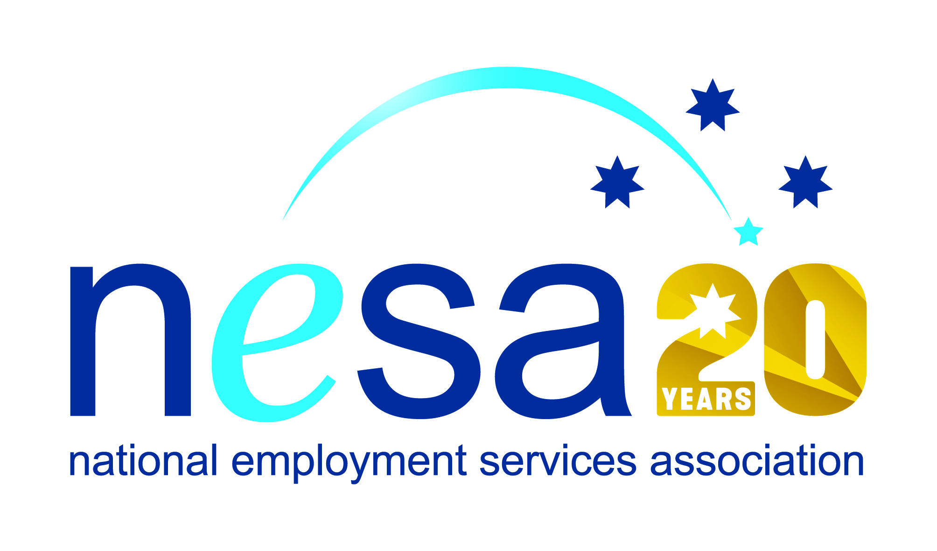

MEDIA RELEASE
22 AUGUST 2017
Bairnsdale’s Shay Terrick is NESA Achiever of the Year
Bairnsdale man Shay Terrick is the winner of the National Employment Services Association (NESA) Achiever of the Year Award. He joins 6 other people and organisations honoured in the NESA Awards for Excellence ceremony held this evening at the Pullman Melbourne on the Park, as part of NESA’s 2017 National Conference.
“Shay has shown exceptional dedication and commitment to improving his situation for himself and his young family. Overcoming a range of challenges and hurdles that might have made many others give up, Shay stuck with it and took full advantage of the support and resources made available to him by his employment services provider Mission Providence.
“Shay’s story is an excellent example of how lives can be transformed through inclusive employment,” said NESA CEO Sally Sinclair. “Australian employment services assist people to gain the skills and opportunities they need to turn their lives around. Shay took advantage of every opportunity to maximise his chances of success in his hunt for employment. He worked hard to improve his interpersonal skills, got his driver’s licence, and accrued work experience through Work for the Dole, and his hard work has paid off.”
Shay is now a proud member of the Gunaikurnai Land and Waters Aboriginal Corporation, fulfilling the vital role of Cultural Heritage Coordinator.
“It means the world to me to be able to support my family in the way that they deserve.” Shay said. “To be able to afford the extra little things in life that I couldn’t before and to be able to take my family out and spoil them. It’s been a real eye opener to life in general to go from sitting around with not much to do, to being full time employed. It has given me a real purpose in life and also given me the opportunity to be able to plan for the future with my family.”
NESA joins Mission Providence in congratulating Shay on his new position, and on his recognition with this national award. “Well done, Shay, on your achievements, and on your well-earned win.” said Sally Sinclair.
The National Employment Services Association Achiever of the Year Award is supported by the Australian Government Department of Employment.
…ends/

