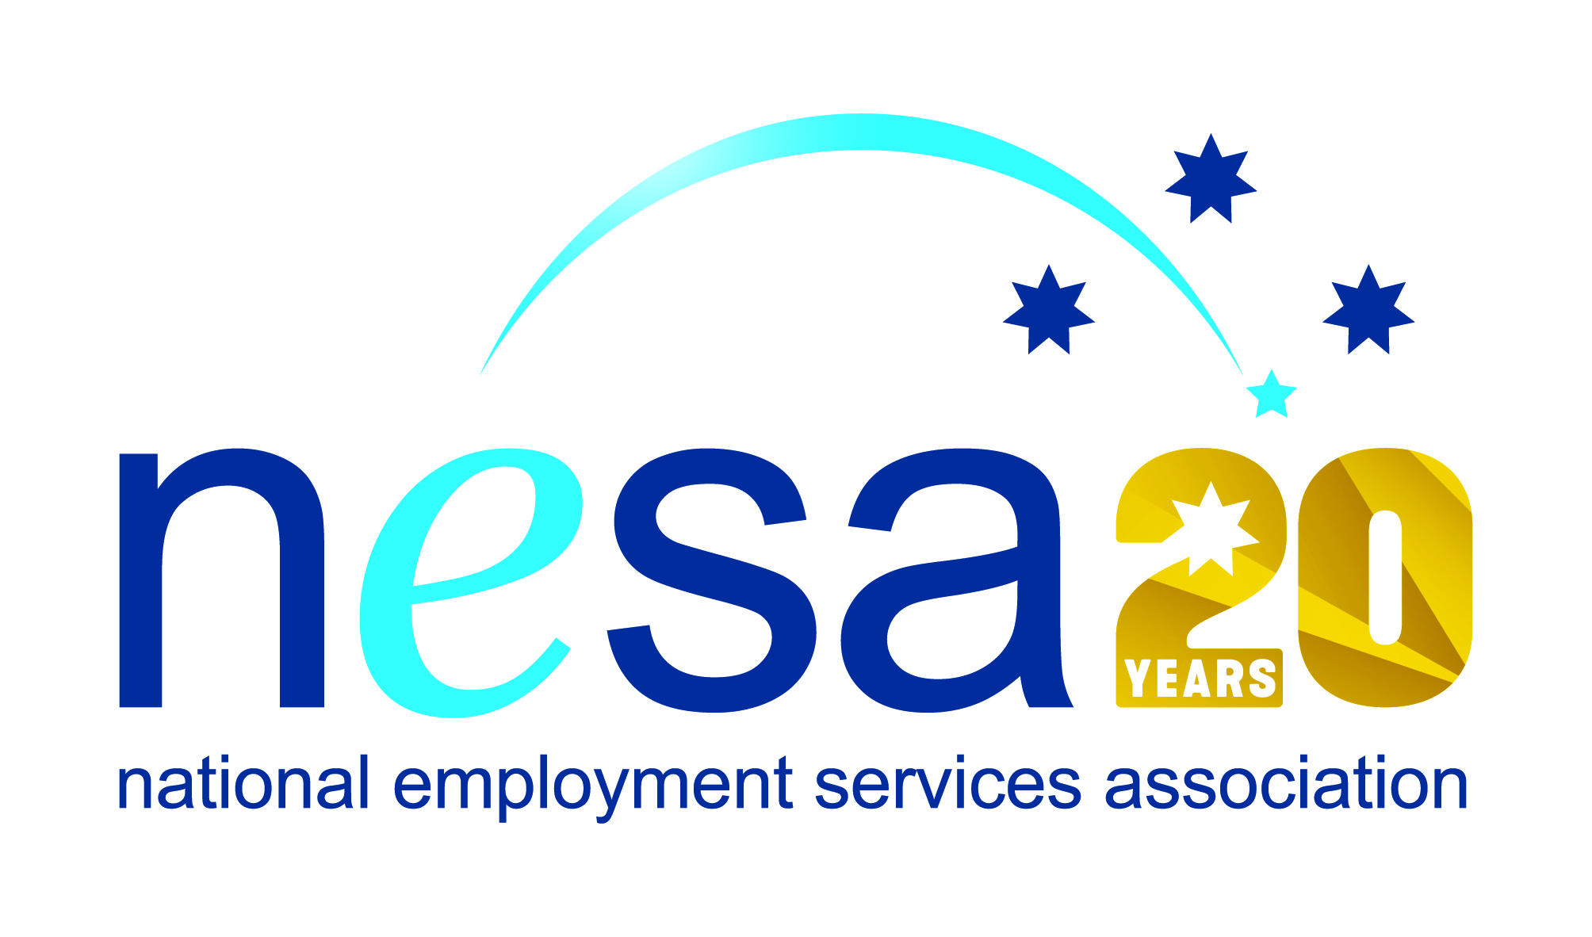

MEDIA RELEASE
MONTH YEAR
Local Bairnsdale lad recognised for his outstanding commitment
Bairnsdale local Shay Terrick has been nominated for the National Employment Services Association (NESA) Achiever of the Year Award by Mission Providence, in recognition of his exceptional dedication and commitment in turning his life around for himself, and his young family. This is one of five Awards for Excellence offered each year by NESA for outstanding performance and achievement within the employment services sector.
Shay has overcome a range of challenges and hurdles that might have made others give up: out of work, down on himself, lacking qualifications and transport. But not Shay: he stuck with it, and took full advantage of the resources made available for him by his employment services provider. Shay worked with Mission Providence to improve his interpersonal skills, got his driver’s licence, and accrued work experience through the Work for the Dole programme. He took every opportunity to maximise his chances of success.
And what success! Shay is now a proud part of the Gunaikurnai Land and Waters Aboriginal Corporation, fulfilling the vital role of Cultural Heritage Coordinator. Shay’s HR Manager, Mardi Edwards said of him “[e]very working day, he shows me that he is keen to be the best he can be. […] I support Shay as a hard working, determined person who has changed his life.”
“It means the world to me to be able to support my family in the way that they deserve.” Shay said. “To be able to afford the extra little things in life that I couldn’t before and to be able to take my family out and spoil them. It’s been a real eye opener to life in general to go from sitting around with not much to do, to being full time employed. It has given me a real purpose in life and also given me the opportunity to be able to plan for the future with my family.”
NESA joins Mission Providence in congratulating Shay on his new position, and offering our respect and admiration for his hard-earned success. “Dedicated people like Shay are an excellent example of how the Australian employment services can provide determined people with the skills and opportunities they need to turn their lives around,” said NESA CEO Sally Sinclair. “Congratulations Shay on your achievements, and your well-earned nomination.”
The winner of the National Employment Services Association Achiever of the Year Award will be announced at the NESA National Conference, to be held in Melbourne on the 22nd- 23rd of August, 2017.
The National Employment Services Association Achiever of the Year Award is supported by the Australian Government Department of Employment. …ends/

