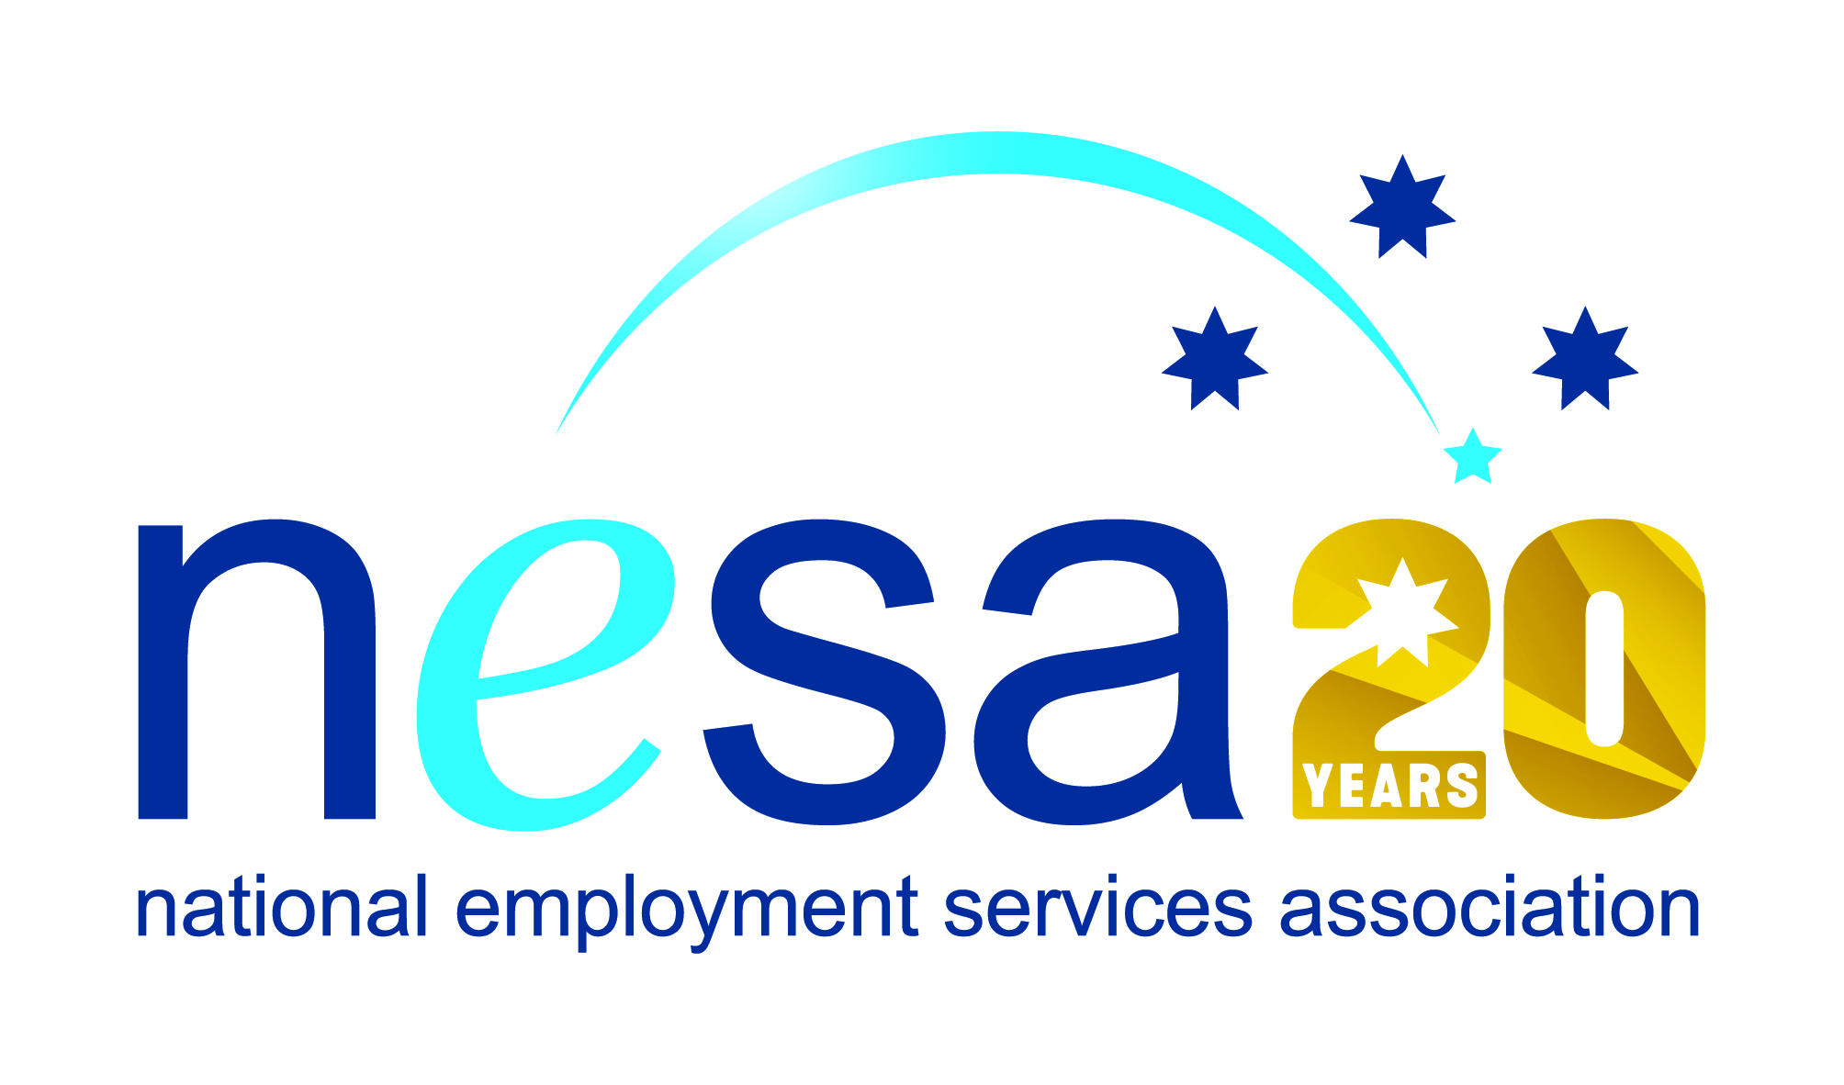

MEDIA RELEASE
3 AUGUST 2017
National award nominee says, “Without you…I wouldn’t still be here.”
We all have challenges in our lives, but Kevin Moore faced challenges that go far beyond what most of us ever have to deal with. Kevin has been nominated for a National Employment Services Association (NESA) Achiever of the Year Award by Artius, in recognition of his extraordinary determination in rising above these challenges and turning his life around. This is one of five Awards for Excellence offered each year by NESA for outstanding performance and achievement within the employment services sector.
Kevin now has an email address, a phone, a comfortable apartment and a stable job. He is regaining a circle of friends. These are things that so many of us take for granted, but Kevin had to work hard to get them back.
And work hard he did. With the untiring support of his employment consultant at Artius, Karen McLean, Kevin was able to rebuild his confidence, his self-esteem, become requalified and find the work that he wanted. “Your belief in me helped to get strong to get a life with control, employment, friends and success,” Kevin said. “Without you, Karen, and the Artius team, I wouldn’t still be here.”
These are not glib words. Kevin had lost more than most of can imagine. But they are modest words, because they fail to underscore Kevin’s own remarkable resilience and determination. Nobody did this for him: he did it himself. He did not pass his qualification the first time round, but had to redo it, more than once. He did not find a job straight away, but persisted day in and day out for weeks until an opportunity presented itself.
“Kevin is a moving example of what people can achieve when someone believes in them,” said NESA CEO Sally Sinclair. “Kevin’s story is testament to his own strength of character and to the dedicated employment services practitioners at Artius, who were unwavering in their support of this man as he rebuilt his life. Congratulations Kevin on turning your situation around and on your well-earned nomination.”
The winner of the National Employment Services Association Achiever of the Year Award will be announced at the NESA National Conference, to be held in Melbourne on the 22nd -23rd of August, 2017.
The National Employment Services Association Achiever of the Year Award is supported by the Australian Government Department of Employment. …ends/

