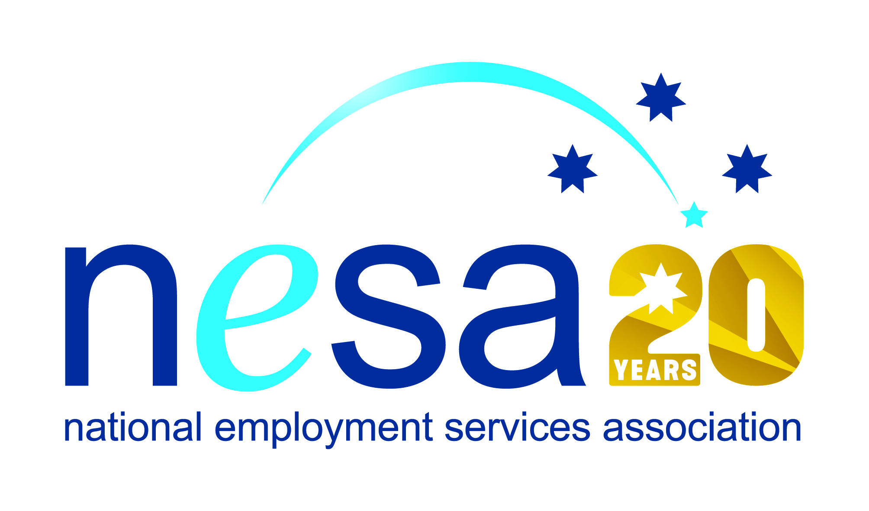

MEDIA RELEASE
22 AUGUST 2017
Rob Beattie wins national award for his work with Indigenous job seekers
Former RAAF officer Rob Beattie, who now works for atWork Cannington, is the winner of the National Employment Services Association (NESA) Excellence in Indigenous Employment Award. Rob joins 6 other people and organisations honoured in the NESA Awards for Excellence ceremony held this evening at the Pullman Melbourne on the Park, as part of NESA’s 2017 National Conference.
“Rob Beattie is the kind of employment services practitioner who makes a positive and lasting impact on people’s lives and well-being,” said Sally Sinclair, NESA CEO. “Rob’s particular devotion and outstanding successes are examples to us all.”
Rob has been working with atWork since 2013, where his good-natured and tireless dedication has won him great respect and admiration amongst those he has assisted.
“He goes out of his way to help his job seekers, and is respected within the Indigenous community where he is well liked and considered a top bloke,” said one of Rob’s clients, or ‘mates’ as they refer to themselves: “He also gives me and other mates lifts when he sees us on the street.”
Over the course of his time in employment services, Rob has developed close and effective relationships with a number of Indigenous organisations in the Perth metropolitan area including the Aboriginal Workforce Development Centre (AWDC), the Derbal Yerrigan Health Service and Aboriginal Hostels Ltd. He also teaches job seeking classes for the Aboriginal Services Unit at South Metropolitan TAFE.
Trusted and respected, Rob’s dedication and hard work are evident in his exceptional retention rate: 70% of his clients achieve 52 week sustained employment milestone.
“Rob shows a very good understanding of Aboriginal people and has a deep respect for our culture,” said Michele Halse Aboriginal Workforce Development Consultant, South Metropolitan TAFE. “He has a great sense of humour and works steadily to provide skills and motivation to the Aboriginal clients, as well as being a mentor.”
NESA joins atWork in congratulating Rob on his well-deserved win.
The National Employment Services Association Excellence in Indigenous Employment Award is supported by the Australian Government Department of Employment.
…ends/

