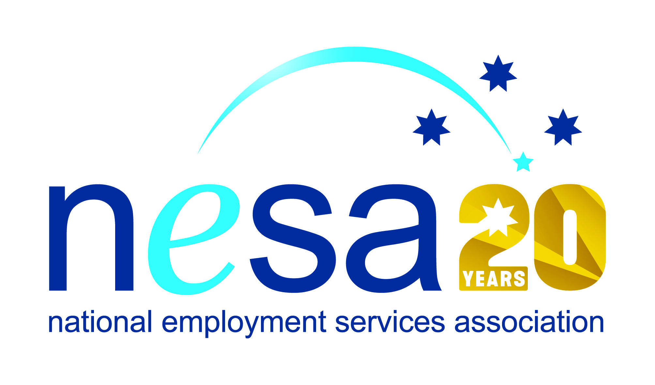

MEDIA RELEASE
4 AUGUST 2017
Proserpine team meet Indigenous employment challenges head-on
A team of three dedicated employment services practitioners from CoACT Community Solutions, Proserpine have been nominated for the National Employment Services Association (NESA) Excellence in Indigenous Employment Award. This is one of five Awards for Excellence offered each year by NESA for outstanding performance and achievement within the employment services sector.
Tina West, Kim Clegg and Lesley England have shown outstanding dedication to the Indigenous community that they serve, helping CoACT Community Solutions, Proserpine to achieve and maintain the sector’s coveted 5-Star performance rating.
With few Indigenous support services in the region, Tina, Kim and Lesley took advantage of Queensland State government’s Youth Boost employer incentives, creating their own programme in partnership with Acclaim Apprentices and Trainees, called Host2Hire.
The strength of the Host2Hire approach was its sensitivity to Aboriginal culture. Rather than working with Indigenous job seekers individually, Tina’s team reorganised their employer engagement model to allow for a community and family-oriented approach, more in line with Indigenous expectations. The traditional one-on-one interview process was replaced by small networking events between Indigenous job seekers and local employers. They also encouraged employers to be sensitive to cultural considerations for Indigenous people, and to allow a period of adaptation for new employees to get accustomed to the rhythm and expectations of their new workplace.
The results were immediate, and the Host2Hire approach has quickly become the Best Practice model in the region.
“Tina, Kim and Lesley’s Host2Hire programme is an excellent initiative, showing sensitivity to Indigenous culture, as well as a smart use of available funding sources, and an outstanding engagement model,” said NESA CEO Sally Sinclair.” It is this kind of outside-the-box thinking that inspires new generations of employment services practitioners and greatly enhances the life-changing work that these unsung heroes do! Well done!”
The winner of the NESA Excellence in Indigenous Employment Award will be announced at the NESA National Conference, to be held in Melbourne on the 22nd- 23rd of August, 2017.
The National Employment Services Association Excellence in Indigenous Employment Award is supported by the Australian Government Department of Employment. …ends/

