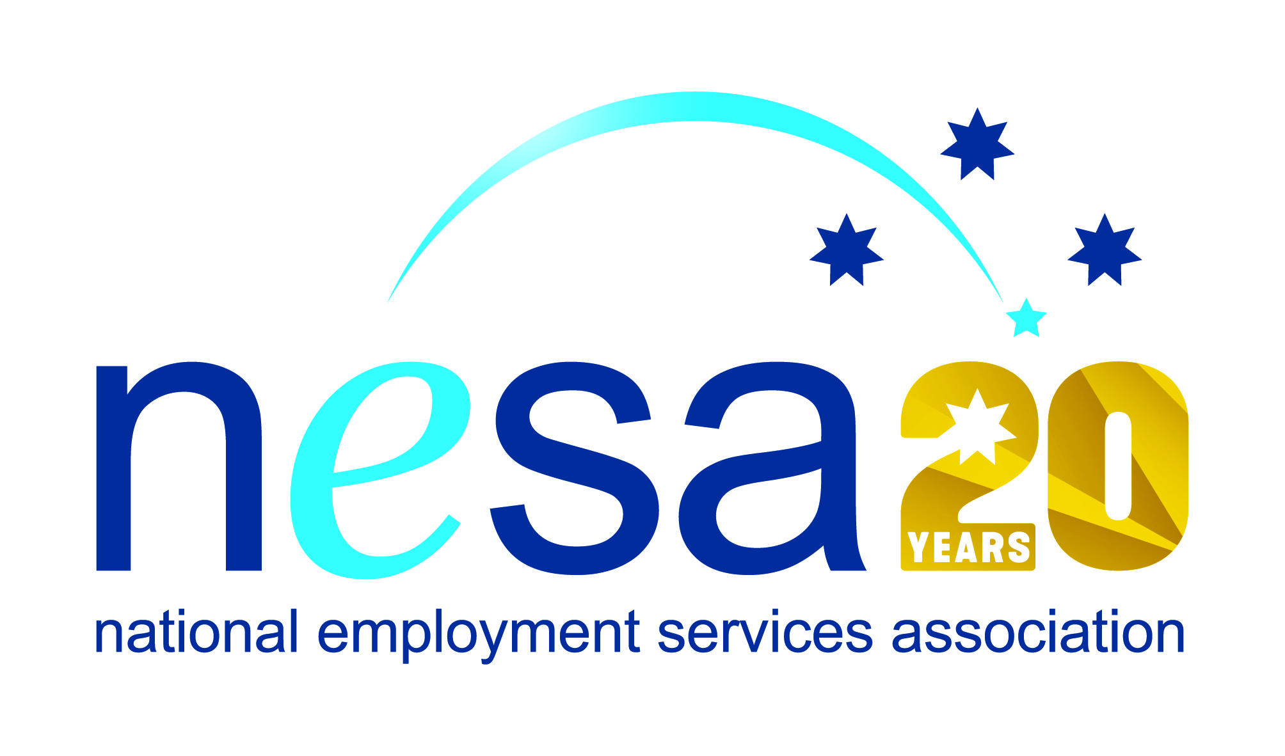

MEDIA RELEASE
22 AUGUST 2017
Putting people first wins Silly Yak Foods a national award
Coburg-based handmade wheat, gluten and nut-free baked goods manufacturer Silly Yak Foods is the 2017 National Employment Services Association (NESA) Champion Employer of the Year. They join 6 other people and organisations honoured in the NESA Awards for Excellence ceremony held this evening at the Pullman Melbourne on the Park, as part of NESA’s 2017 National Conference.
“It is very encouraging to see small to medium enterprises like Silly Yak embracing the possibilities offered by employment services to improve opportunity and inclusion for disadvantaged Australians,” said NESA CEO, Sally Sinclair. “Their highly successful collaboration with employment services provider MatchWorks is an example to be followed.”
Silly Yak are a local success story, growing from a small Northcote café in 2001 to an international distributor of quality products. As they grew, their commitment to creating a supportive work environment grew with them. In 2013 they formed an exclusive partnership with MatchWorks, whom they saw as an organisation sharing their commitment to getting disadvantaged people into secure, permanent, ongoing employment.
The company only has permanent employees. “By providing an open, inclusive, flexible and family friendly environment, as well as employing people only in permanent positions, we encourage a sense of belonging and community in our staff,” said Managing Director Bryn Pears.
Silly Yak looks at each potential employee as the person they are now, and what they can bring to the organisation moving forward. “Our staff recruitment process is largely indifferent to the applicant’s past travails, what matters is character and desire to work, not mistakes made earlier in life,” he said.
Most of the company’s 18 staff have been employed through their relationship with MatchWorks, jobactive and Disability Employment Services.
NESA congratulates the team at Silly Yak Foods whose commitment to inclusive employment has enabled disadvantaged job seekers to transform their lives through employment. “The excellence in diversity recruitment shown by Silly Yak Foods recognised through this award, shows that you don’t have to be a large employer to make a difference and contribute to addressing disadvantage,” said Sally Sinclair. “Silly Yak Foods are a well-deserving winner of this award and should be an inspiration to other employers.”
The National Employment Services Association Champion Employer of the Year Award is supported by the Australian Government Department of Employment.
…ends/

