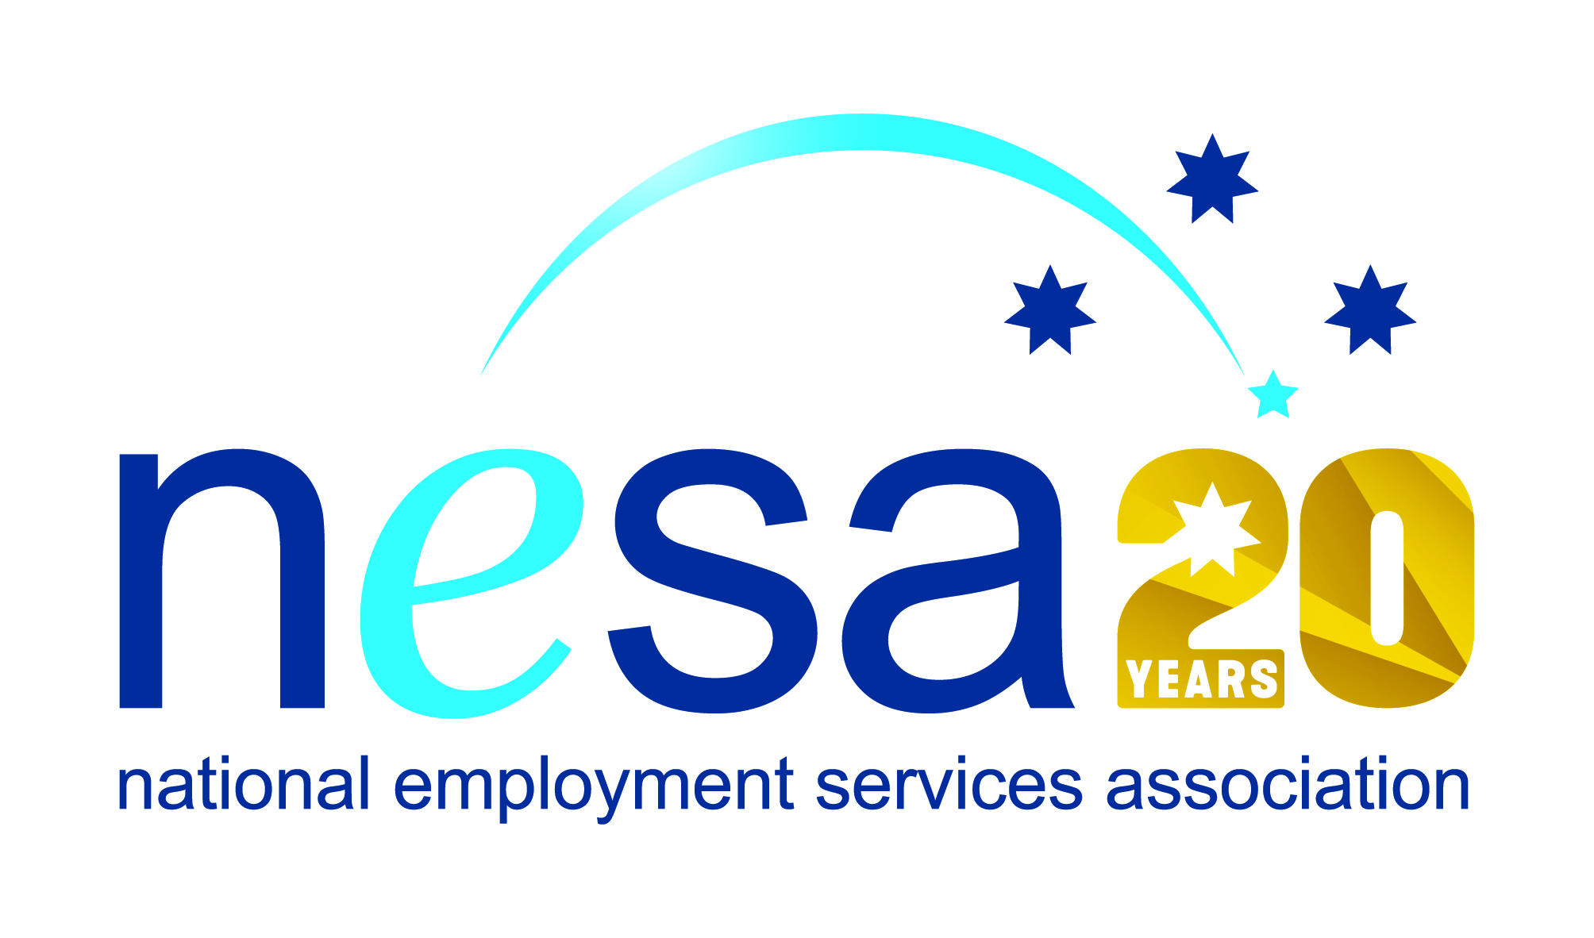

MEDIA RELEASE
4 AUGUST 2017
An employer with heart, committed to making a difference
Chandler Macleod have been nominated for the National Employment Services Association (NESA) Champion Employer of the Year Award. This is one of five Awards for Excellence offered each year by NESA for outstanding performance and achievement within the employment services sector.
Chandler Macleod are a recruitment agency operating throughout Australia, New Zealand and Asia. There are hundreds of such agencies. But what makes Chandler Macleod unique is their genuine commitment to placing the most disadvantaged Australians into work.
The job seeking, application and interview process can itself be almost impossible to negotiate for a great many jobseekers. In most standard, traditional recruitment processes, the onus is on the applicant to prove that they tick all the required boxes. Often it’s “one strike, and you’re out”. Chandler Macleod don’t operate that way. In collaboration with employment services provider atWork Australia, Chandler Macleod offer a supportive selection and pre-employment training structure that allows job seekers with particular barriers to employment to find alternative ways to demonstrate their job-readiness. Rather than the normal impersonal hurdles to jump, Chandler Macleod offers a helping hand.
And the results are impressive: 100% attendance rate at their pre-employment training programme, and 85% placement into employment following training.
"Chandler Macleod are an employer with heart, who go above and beyond standard practice and are committed to making a difference to the lives of the most disadvantaged Australians via long-term, sustainable employment," said atWork's General Manager, Michael Kolomyjec.
NESA CEO Sally Sinclair praised the collaboration, saying “Chandler Macleod have developed a recruitment model in direct collaboration with NESA’s valued member, atWork Australia, that shows what can be done with imagination and a genuine commitment to placing people into work. We congratulate them on this well-deserved nomination.”
The winner of the NESA Champion Employer of the Year Award will be announced at the NESA National Conference, to be held in Melbourne on the 22nd- 23rd of August, 2017.
The National Employment Services Association Champion Employer of the Year Award is supported by the Australian Government Department of Employment.
…ends/

