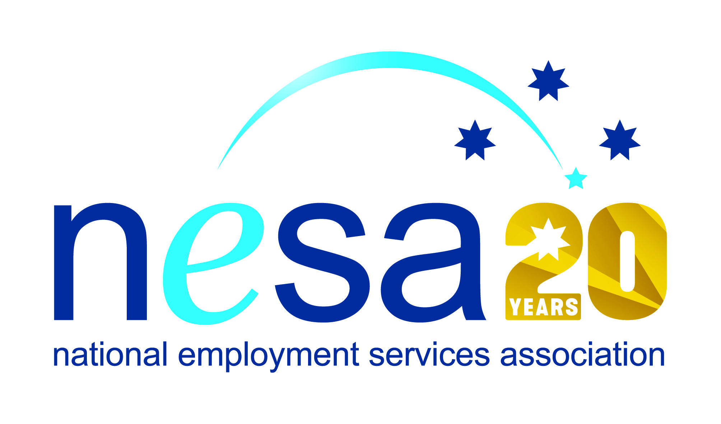

MEDIA RELEASE
22 AUGUST 2017
Bundaberg recycler takes out national award
CoAct member IMPACT Community Services, Bundaberg, has won the 2017 National Employment Services Association (NESA) Innovation in Disability Employment Team Award. They join 6 other people and organisations honoured in the NESA Awards for Excellence ceremony held this evening at the Pullman Melbourne on the Park, as part of NESA’s 2017 National Conference.
“IMPACT chose their name well!” said Sally Sinclair, NESA CEO. “Their work positively impacts the environment, the lives of their employees and the prospects and situation of people with disability everywhere. Their business model is an inspiring example of what can be done with imagination, compassion and a genuine desire to make a difference.”
IMPACT’s Bundaberg Material Recovery Facility plays an essential role in the recycling process. Last year IMPACT recovered in excess of 7,500 tonnes of recyclable material; they recycled 5,880 tonnes of paper and cardboard and their activities prevented 12,180 tonnes of CO2 from being released into the environment.
But if IMPACT’s achievements for the environment are impressive, their commitment to people with disability is even more so. IMPACT’s top priority is making a difference to the community through the values of trust; empowerment; relevance; compassion and inclusiveness. IMPACT are strong advocates for the employment rights of people living with disability.
Their commitment is evident at the Bundaberg facility which has 33 staff, of whom 27 are people living with disability. IMPACT’s approach to creating a supportive workplace has resulted in extremely high employee satisfaction and engagement that motivates staff to deliver excellence in service and high productivity. Employees feel needed, appreciated and relied upon as members of the IMPACT team and know their work is making a meaningful contribution to the local environment and economy.
NESA whole-heartedly congratulates CoACT IMPACT Community Services on this well-deserved win.
The Innovation in Disability Employment Team Award is supported by the Australian Government Department of Social Services
…ends/

