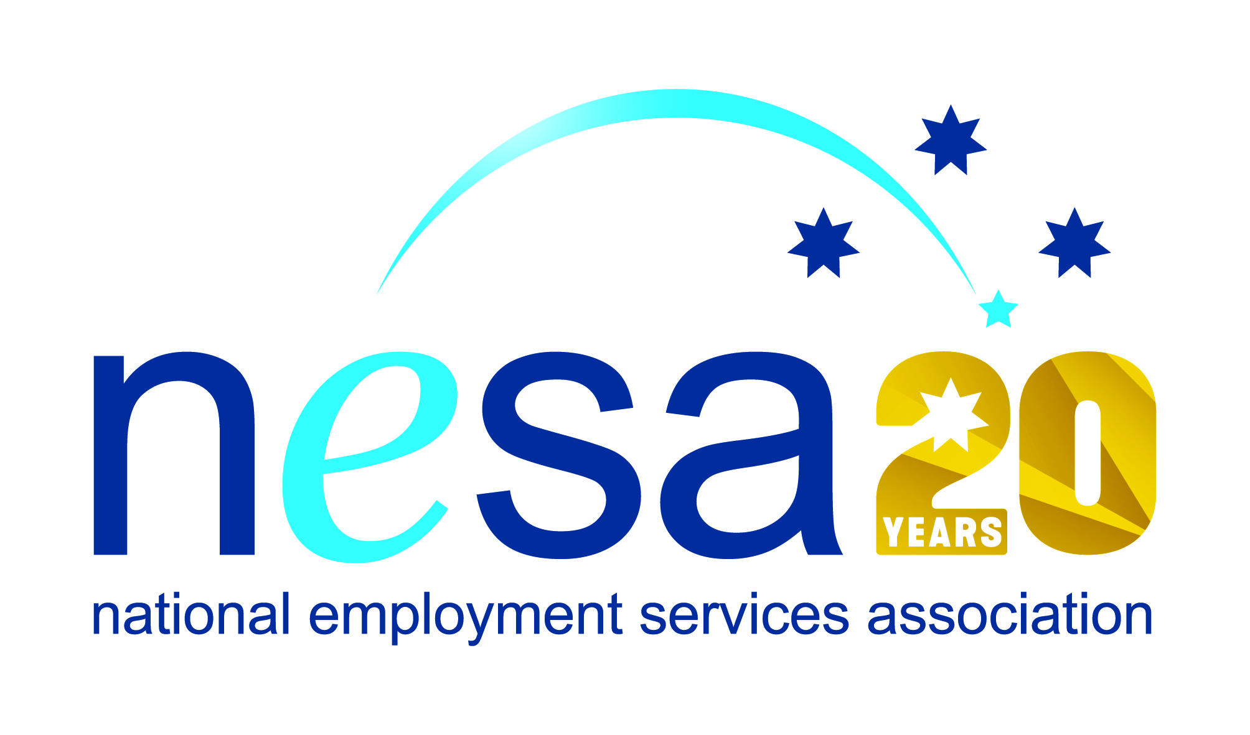

MEDIA RELEASE
3 AUGUST 2017
Kellie is all about engagement and endurance!
NSW’s Orana region is fraught with employment challenges. It has one of the nation’s highest unemployment rates, and lowest household incomes. Kellie Reeves, Senior Employment Consultant with Interact People Solutions (IPS), Dubbo, has worked in this region for three and half years and in that time has made a real impact. She has been nominated for the National Employment Services Association (NESA) Employment Consultant of the Year Award in recognition of her stellar performance in getting people into work, despite these local challenges. This is one of five Awards for Excellence offered each year by NESA for outstanding performance and achievement within the employment services sector.
Kellie grabs life with both hands. When she is not at work, she is running 50km endurance runs, fulfilling the role of Secretary of the local Junior Soccer Club or contributing to one of the many charitable organisations of which she is an active member. Her devotion to her region drives her to constantly look for new ways to add value to the lives of those around her.
In her position with IPS, Kellie has been tireless in improving her own skills and those of her colleagues. IPS acknowledge her pivotal role their recent 5 Star performance rating from the Department of Social Services. Her skills extend to improvements in internal office workflow, staff training and the creation of online resources.
But Kellie is above all an employment services consultant and in that role, she is changing lives. She regularly goes out of her way to meet with clients more frequently than required to guarantee engagement. She stresses positivity and ability, focussing always on the ‘can’, and the ‘do’: positive change, positive decision-making, goal setting, and goal achievement. She leads by example, letting her enthusiasm and positive outlook inspire others. And clearly, it works!
“Kellie is the kind of person whose infectious positivity raises everybody’s game, “said NESA CEO Sally Sinclair. “Her exemplary work for IPS has changed the lives of hundreds of job seekers, and made her work environment a better place at the same time. I am very happy to see someone like Kellie recognised with this well-deserved nomination!”
The winner of the National Employment Services Association Employment Consultant of the Year Award will be announced at the NESA National Conference, to be held in Melbourne on the 22nd -23rd of August, 2017.
…ends/

