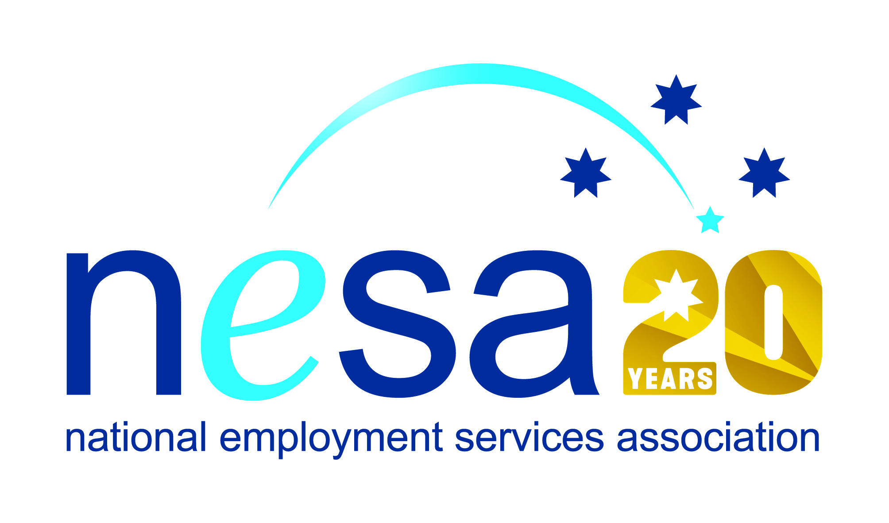

MEDIA RELEASE
3 AUGUST 2017
“It’s not about the ‘knock down’ but about the ‘get up’”, says national award nominee.
Kayleen Perrotto, of Interact People Solutions, Mudgee has been nominated for the National Employment Services Association (NESA) Employment Consultant of the Year Award. This is one of five Awards for Excellence offered each year by NESA for outstanding performance and achievement within the employment services sector.
In her role as a Senior Employment Consultant, Kayleen is one of the 30 thousand people across Australia who help fellow Australians to find work. Everyone who works in the employment services can be proud of the positive impact they have on people’s lives, but Kayleen stands out. She helps people with disability, people with addiction issues, people with language barriers, people with depression… and victims of family violence. And Kayleen knows all about family violence…
She was herself a victim of abuse before finding the courage to flee with her two young children. The decision was hard, as was the struggle to find her feet, and to provide for her children, but Kayleen’s particular strength derives from her ability to remain focussed on the positive. Described as an “engaging, proactive and positive individual”, she believes that everyone has the ability to make a meaningful contribution to society and to life. And she is indeed a living example.
“It’s not about the ‘knock down’ but about the ‘get up’” she says, smiling. She fundamentally believes that passion for what you do, a positive outlook, proactive advocacy and belief in others can achieve amazing results.
“Kayleen is the kind of person who empowers you with her smile,” said NESA CEO, Sally Sinclair. “Helping people into employment can be hard and draining work, but irrepressible spirits like Kayleen light the way, and recharge the batteries of everybody around them! Congratulations Kayleen on your well-deserved nomination.”
The winner of the National Employment Services Association Employment Consultant of the Year Award will be announced at the NESA National Conference, to be held in Melbourne on the 22nd -23rd of August, 2017.
…ends/

