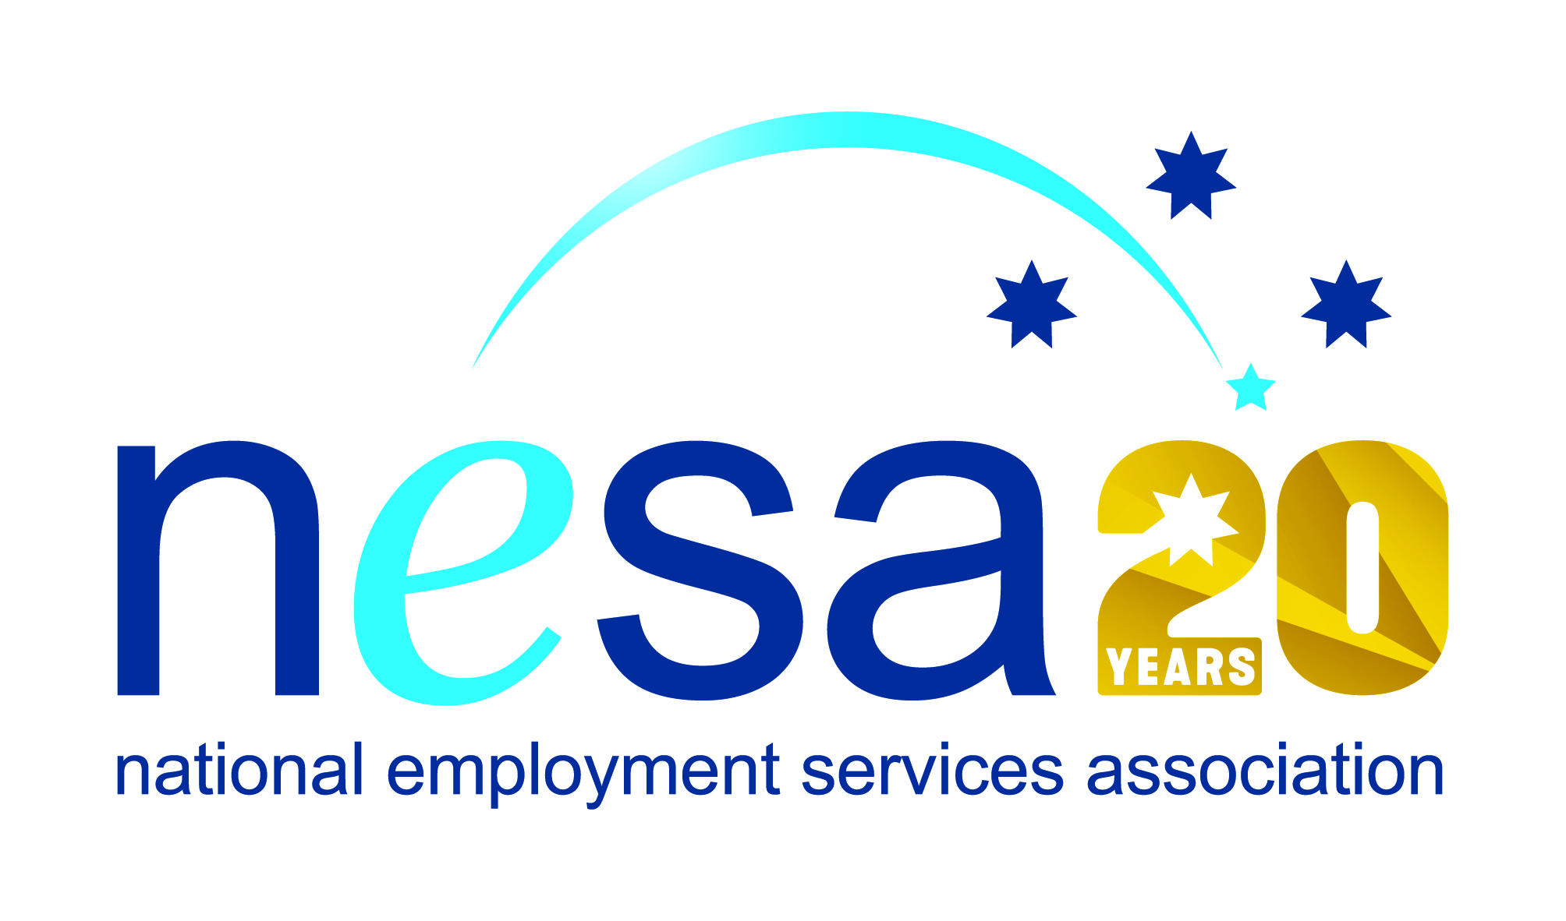

MEDIA RELEASE
3 AUGUST 2017
Elsa understands migrant employment challenges
Elsa Toro of MatchWorks, St Albans has been nominated for the National Employment Services Association (NESA) Employment Consultant of the Year Award for her exceptional work with Culturally and Linguistically Diverse job seekers. This is one of five Awards for Excellence offered each year by NESA for outstanding performance and achievement within the employment services sector.
When she was just 16, Elsa and her family were forced from her native Chile by soaring inflation and rampant unemployment. They sought a new start in Australia but it was far from plain sailing. With almost no English, no family or friends and no knowledge of the cultural and social systems, life at first was confusing, frustrating and hard. “Looking back, our initial time in Australia was heartbreaking as I missed terribly all the family and friends we left behind in Chile. I also struggled to integrate with the Australian culture and lifestyle,” she said.
But Elsa’s parents were determined to make a new home in Australia. With the help of friendly neighbours, the family slowly learnt how to get by. Through hard work and determination, Elsa’s parents supported her and her brother, and through her own single-mindedness, Elsa was able to complete her education, to find work and start her own family.
Now a mother of three, Elsa has taken her own experience as a young woman learning how to function in a new country with a new language, as well as her later professional experience with the Housing Commission and the Victorian Police and turned it into a powerful set of tools to help people like she once was, lost and confused in a new environment, struggling to find work and support themselves.
Elsa has worked for MatchWorks now for three years, and her particular empathy and skill with job seekers from non-English speaking backgrounds has set her apart: she regularly has double the Western Melbourne average for successful and durable job placements amongst her clients.
“Having been out of the work force for quite a while now, my self esteem was very low,” said one of Elsa’s recent clients. “Now that I am a contributing member of society again, my confidence in re-organizing my life has multiplied… Once again, thank you.”
“Elsa is an excellent example of a highly professional woman who has turned difficulties in her own background into the empathy that she now uses to support others who are trying to find their way in a new home,” said Sally Sinclair, NESA CEO. “Elsa’s hard work and inspiring achievements are an example to the sector, and we congratulate her on her well-earned nomination.”
The winner of the National Employment Services Association Employment Consultant of the Year Award will be announced at the NESA National Conference, to be held in Melbourne on the 22nd -23rd of August, 2017.
…ends/

