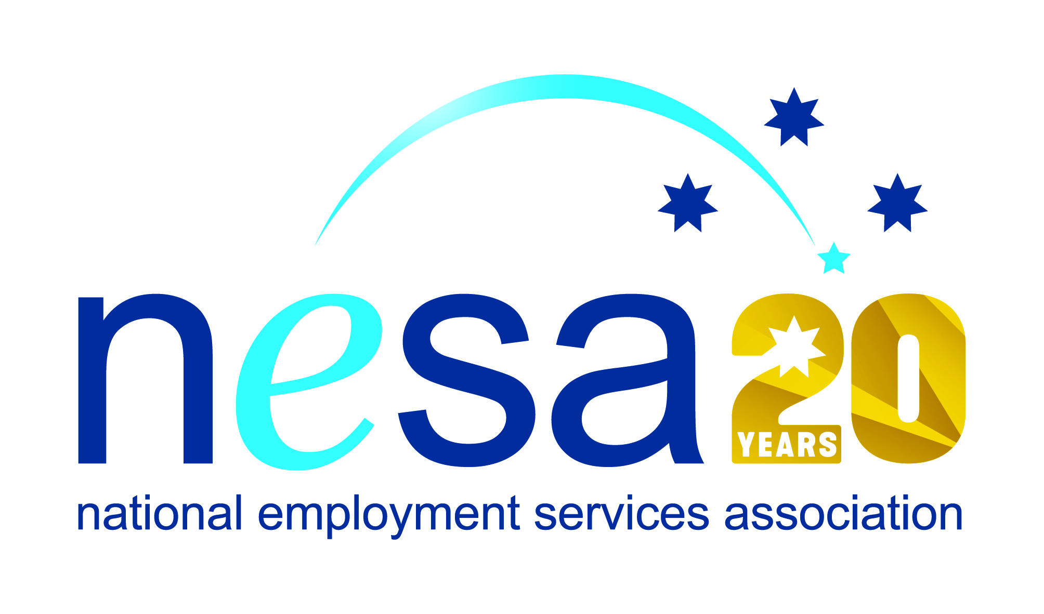

MEDIA RELEASE
3 AUGUST 2017
Jack’s skill and resilience honoured in national award nomination
Jack Macale has been nominated for a National Employment Services Association (NESA) Achiever of the Year Award by atWork Australia, Midland, and that’s probably the last thing he would’ve expected!
One of five Awards for Excellence offered each year by NESA for outstanding performance and achievement within the employment services sector, the Achiever of the Year Award goes to someone who has shown single-minded determination in overcoming considerable hurdles to turn their life around and move into stable employment. This is certainly the case for Jack. As he says himself, “I have fallen down many times, and had some pretty dark days”, but his strength of character has allowed him to take all that and let it become the very thing that now guides him in his position as a Work for the Dole Supervisor with Indigo Junction.
Jack was first noticed by Indigo Junction in his participation in their Strong Fathers Men’s Group. “It was clear to me that he was more of a mentor to the group, rather than just a participant,” said Joanne Dew, Indigo Junction’s Line Manager on the Work for the Dole project. “Once the opportunity of employment for Jack came up at Indigo Junction, Sharon the Program Coordinator went out of her way to ensure that Jack was employed by our service,” she added. “Jack is an inspiration to the participants in the Work for the Dole project.”
Jack has no formal qualifications. His skills come from the ‘school of life’, and his natural compassion and creativity shines through in his ability to turn his own sometimes painful experiences into the strength he now uses to help others. “I cannot believe that I am now assisting people who are in a position where I used to be,” he says, modestly. “The word is out that I’m a good worker, and doors are opening up everywhere.” Jack is also an artist, his painting attracting equal praise.
With the help of his employment services provider atWork Australia, and the supportive team at Indigo Junction, Jack has turned adversity into strength, and NESA joins the voices of those whose lives Jack has touched in offering our respect and admiration for his achievements. “Our Achiever of the Year Award highlights not just hard work and admirable determination, but also making the most of the tools offered by employment services providers,” said NESA CEO Sally Sinclair. “Jack is an excellent example, and we congratulate him on his nomination for this award.”
The winner of the Achiever of the Year Award will be announced at the NESA National Conference, to be held in Melbourne on the 22nd -23rd of August, 2017.
The National Employment Services Association Achiever of the Year Award is sponsored by the Australian Government Department of Employment.
…ends/

